**NAAN MUDHALVAN ASSIGNMENTS**

|  |  |
| --- | --- |
| **NAME** | **VINDHIYA L** |
| **DEPARTMENT** | **B.E - BIOMEDICAL ENGINEERING** |
| **NM ID** | **0F28B4C67A3317EA0A646E15CBE52B4** |
| **NM COURSE** | **DIGITAL MARKETING** |
| **COLLEGE** | **DHANALAKSHMI SRINIVASAN INSTITUTE OF TECHNOLOGY** |

**1.BLOG USING WORDPRESS**

**Link:** <https://elvincafeandrestaurant.wordpress.com/2023/10/10/elvin-cafe-and-restaurant>

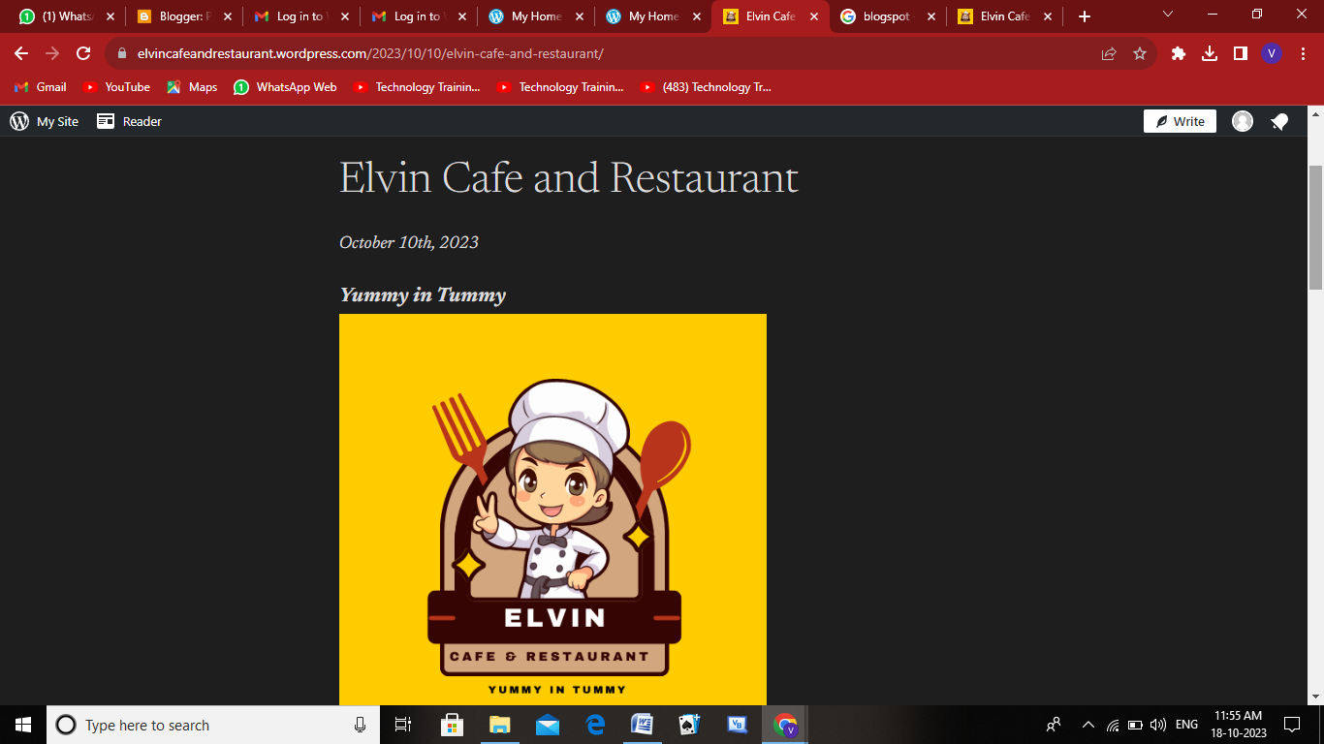

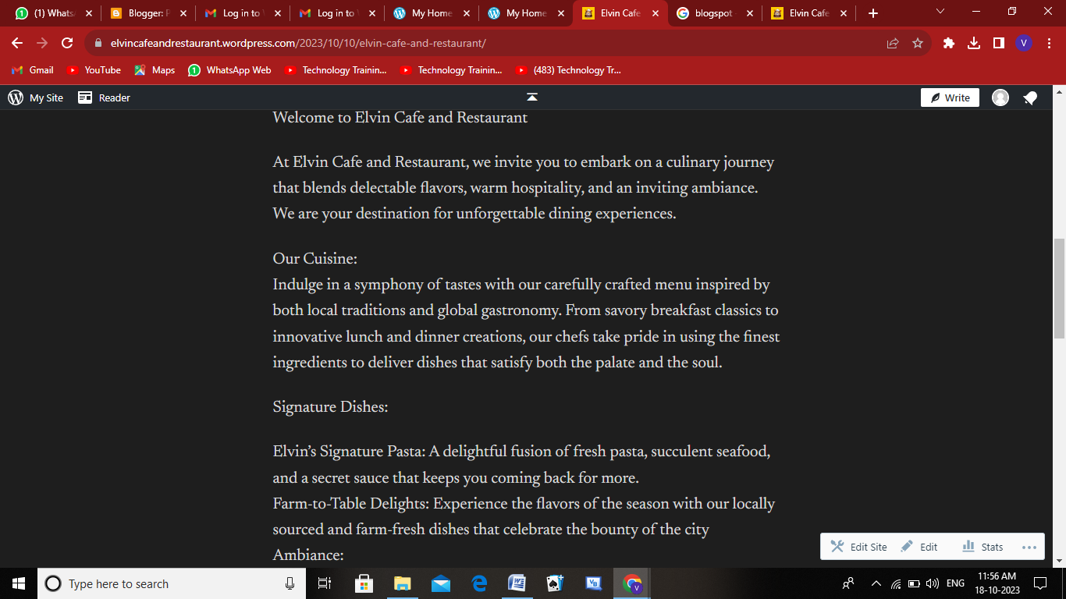

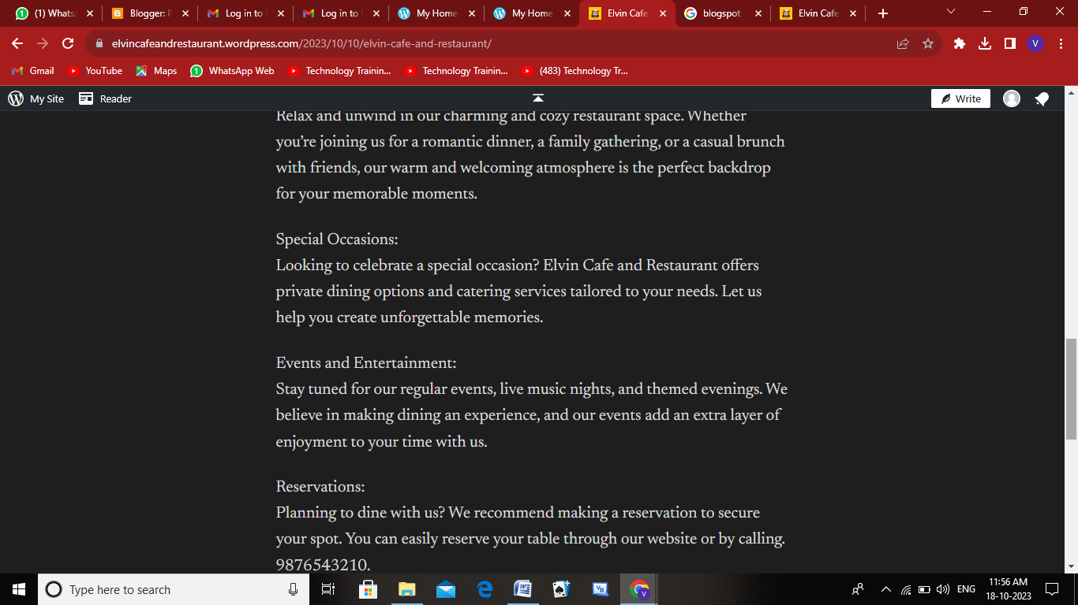

**BLOG USING BLOGSPOT**

**Link:** [**https://www.blogger.com/blog/posts/2767910908203893446**](https://www.blogger.com/blog/posts/2767910908203893446)

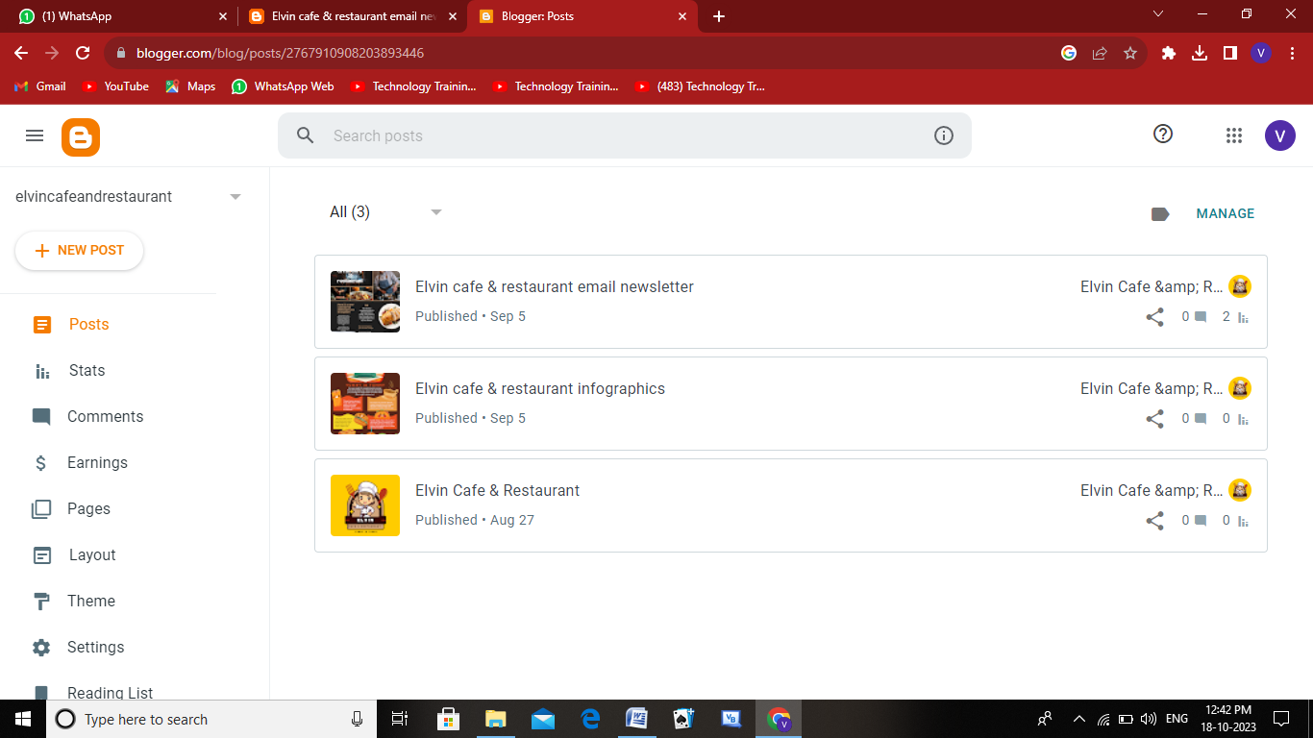

**2.FACEBOOK BUSINESS PAGE & SOCIAL MEDIA POSTER**

**Link:** <https://www.facebook.com/elvincafeandrestaurant>

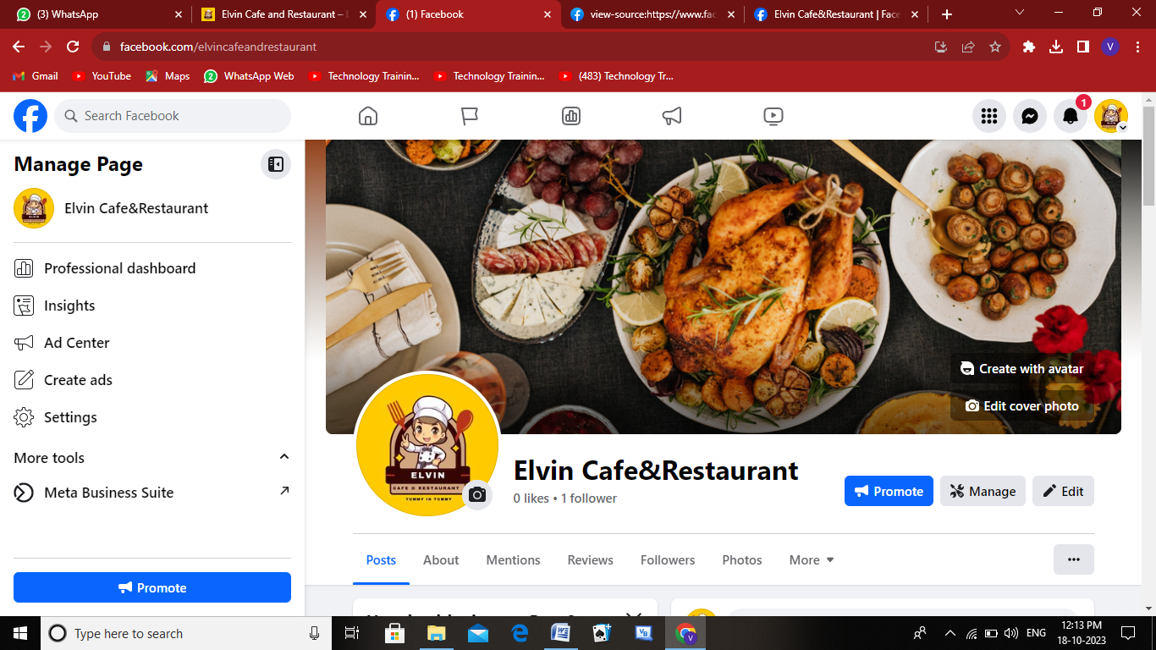

**3.SOCIAL MEDIA ADVERTISEMENT POSTER**

**Link:** <https://www.facebook.com/photo?fbid=122107882064016294&set=a.122107882082016294>

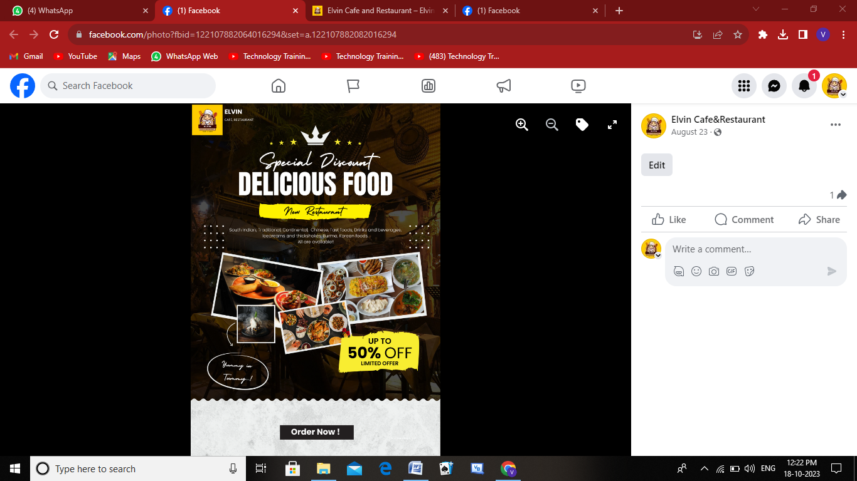

**4.EMAIL NEWSLETTER DESIGN**

**Link:** [**https://elvincafeandrestaurant.blogspot.com/2023/09/elvin-cafe-restaurant-email-newsletter.html**](https://elvincafeandrestaurant.blogspot.com/2023/09/elvin-cafe-restaurant-email-newsletter.html)

